# **2021 合作商家**

## **餐饮类：**

### 火锅 / 烧烤 / 麻辣烫：

#### 

#### 少城公子



Discount Details: 10% off

Address: 660 Dominion Road, Mount Eden, Auckland 1041

Contact：09-638 8800

#### 范特西韩国烧烤

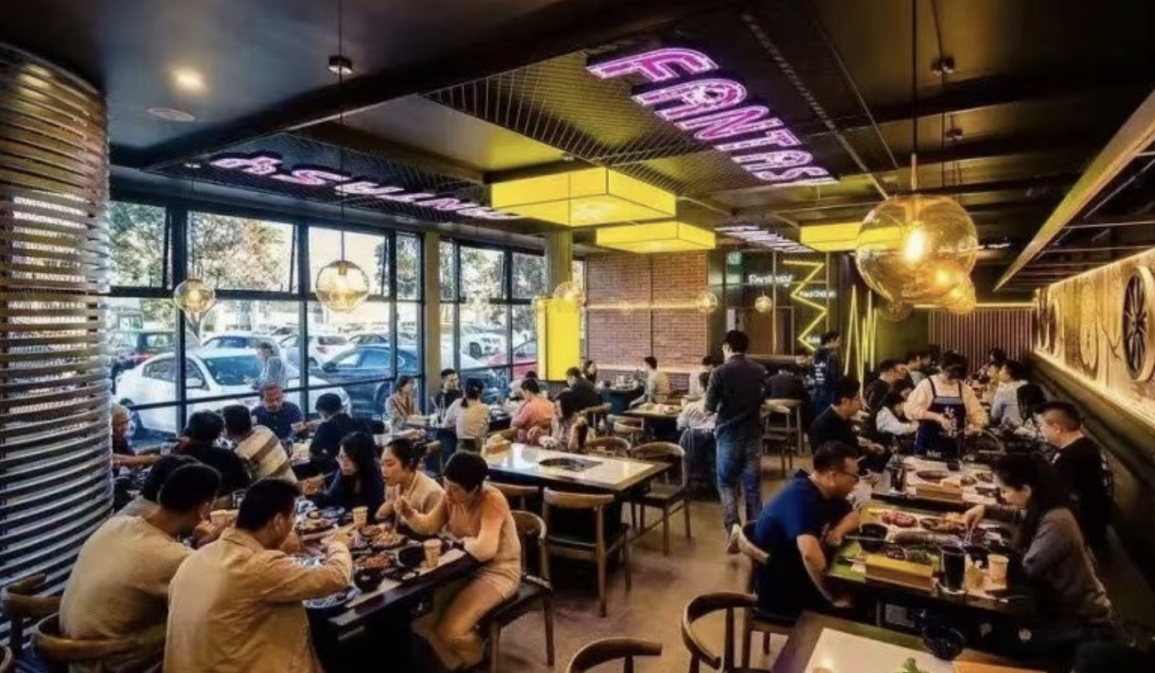

Discount Details: 赠送regular奶茶一杯 (不含topping和特调系列)

Address: 3/83 New North Road, Eden Terrace, Auckland 1021

Contact：0275557677

#### 

#### 牛鲜生



Discount Details: 10% off 可叠加店内12%优惠！

Address: Level 1 50 high street, Auckland CBD

Contact: 09- 2152788

#### 

#### 

#### 亲爱de麻辣烫



北岸店

Discount Details: 10% off

Address: 13/94 Rosedale Road, rosedale, Auckland

Contact: +64273965991

ct店

Discount Details: 免费酸梅汤

Address: 10 Wellesley Street East, CBD, Auckland

Contact: +64223450682

#### 小食尚

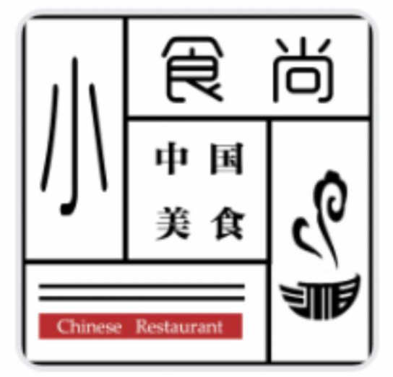

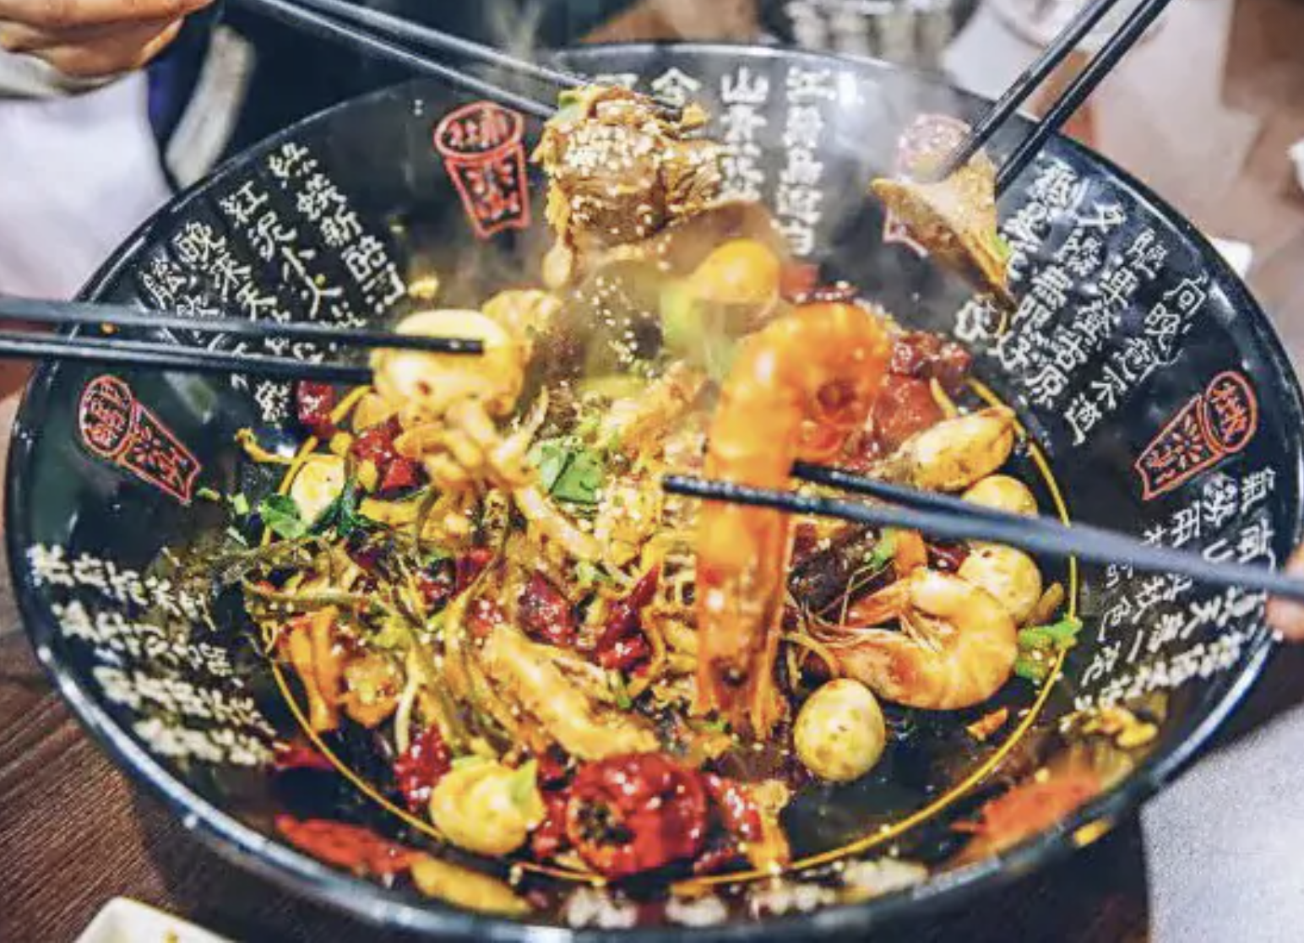

Discount Details: 10% off (spend over $40)

Address: 38 Totara Avenue, New Lynn, Auckland 0600

Contact: 09-2001188

### 

### 

### 中餐 / 简餐：

#### 

#### Chichop 赤炸



Discount Details: 10% Off (Menu Price Item)

Address: Student Quad, 34 Princes St, Auckland Central

#### 

#### 妖茶

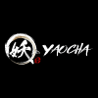 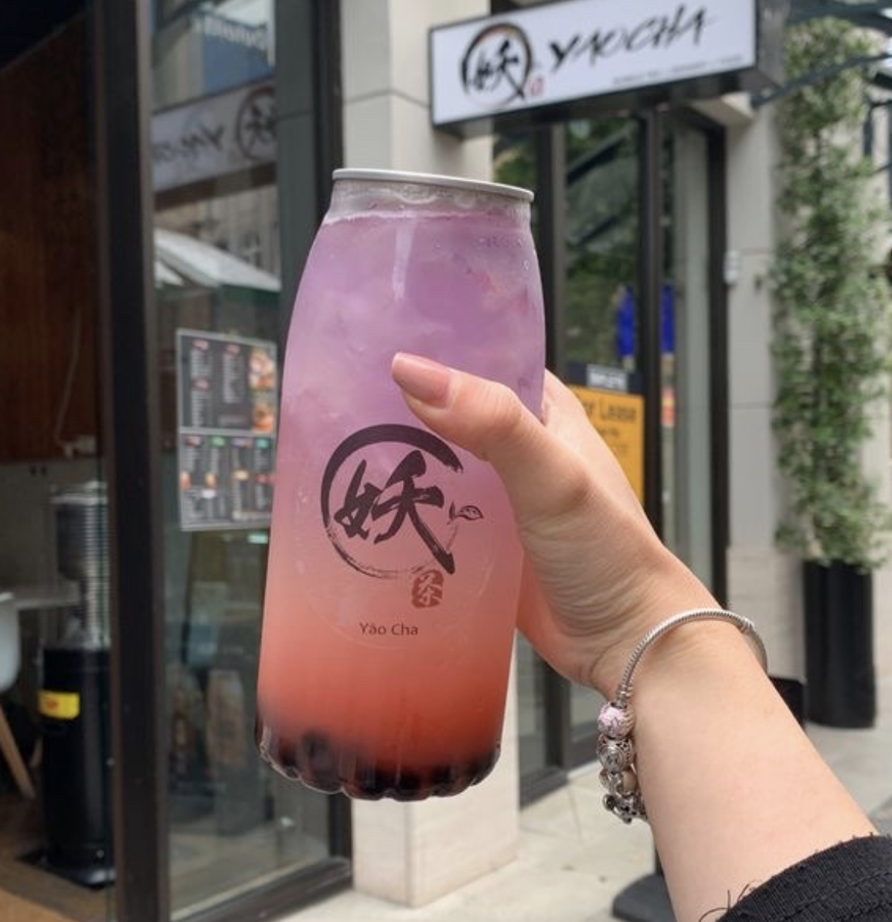

Discount Details: 10% Off

Address: 2A Courthouse Lane, Auckland Central

#### 

#### 

#### 

#### 有食

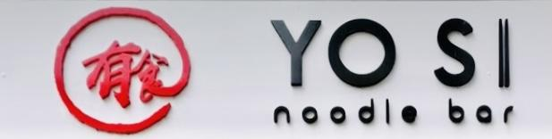

Discount Details: 10% off (Spend over $40)

Address: 2 Kitchener Street, Auckland Central

Contact: 09-379 8578

#### 

#### Sumthin Dumplin

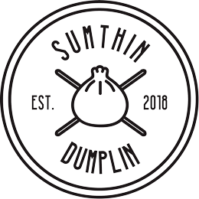

Discount Details: 10% off (Spend over $40)

Address: 18-26 Wellesley Street East, CBD, Auckland 1010

Contact: 09-2189084

#### 

#### 渝味



Discount Details:

1* Free Soft Drink （Spend $20）

2* Free Soft Drink / 红糖冰粉 （Spend $50）

1* Free Cold Dish under $12.8 (Spend $100)

Address: 2/4 Lorne Street, Auckland Central

Contact: 09-377 6789

#### 

#### 

#### 蜀渝



Discount Details:

5% off （Spend under $50）

10% off （Spend over $50）

Address: 26 Lorne Street, Auckland Central

Contact: 09-218 8866

#### 

#### 

#### 

#### 川尚

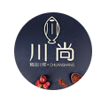

Discount Details: Free sides or soft drink (Spend over $20)

Address: 2m/239 Queen Street, Auckland Central

#### 

#### 周家胡同



Discount Details: 10% off

Address: 6 Durham Street East, Auckland Central

Contact：09-303 0201

#### 笼凤小馆



Discount Details: 10%off

Address: 12/26 Swanson Street, Auckland CBD

Contact: 09-3020086

#### 唐都美食

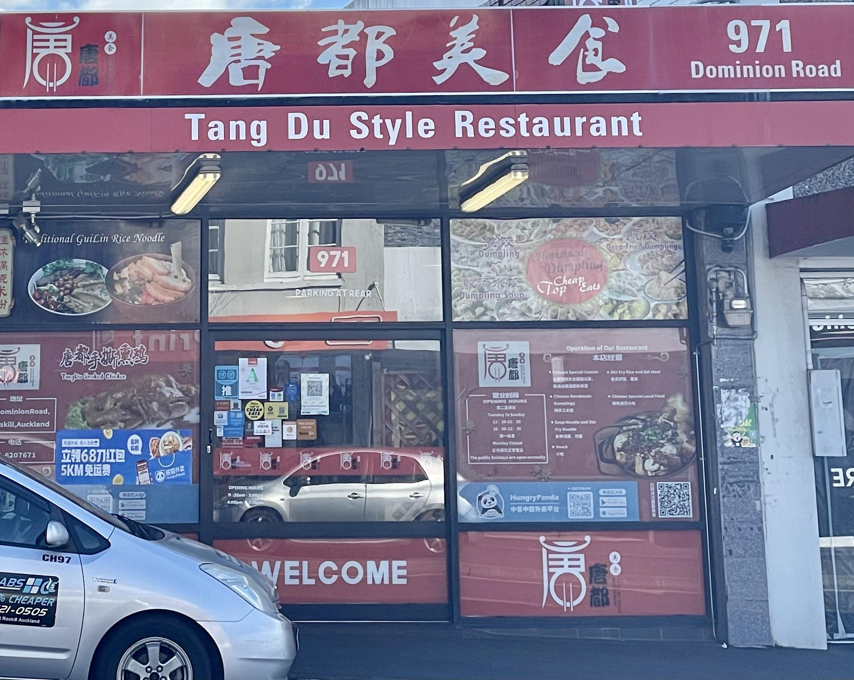

Discount Details: 10%

Address: 971 Dominion Road, Mount Roskill, Auckland 1041

Contact: 09-6207671

#### 

#### 台湾美食

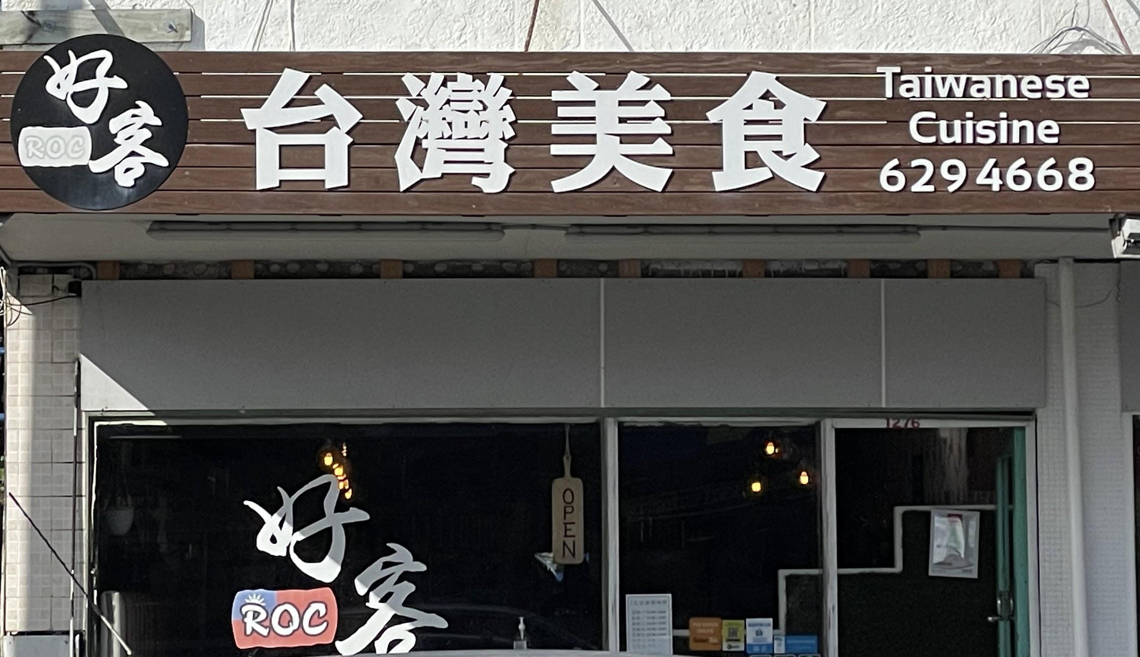

Discount Details: 1* free milktea (spent over $17)

Address: 1276 Dominion Road, Mount Roskill, Auckland 1041

Contact: 09-6294668

#### 

#### 乌鲁木齐美食

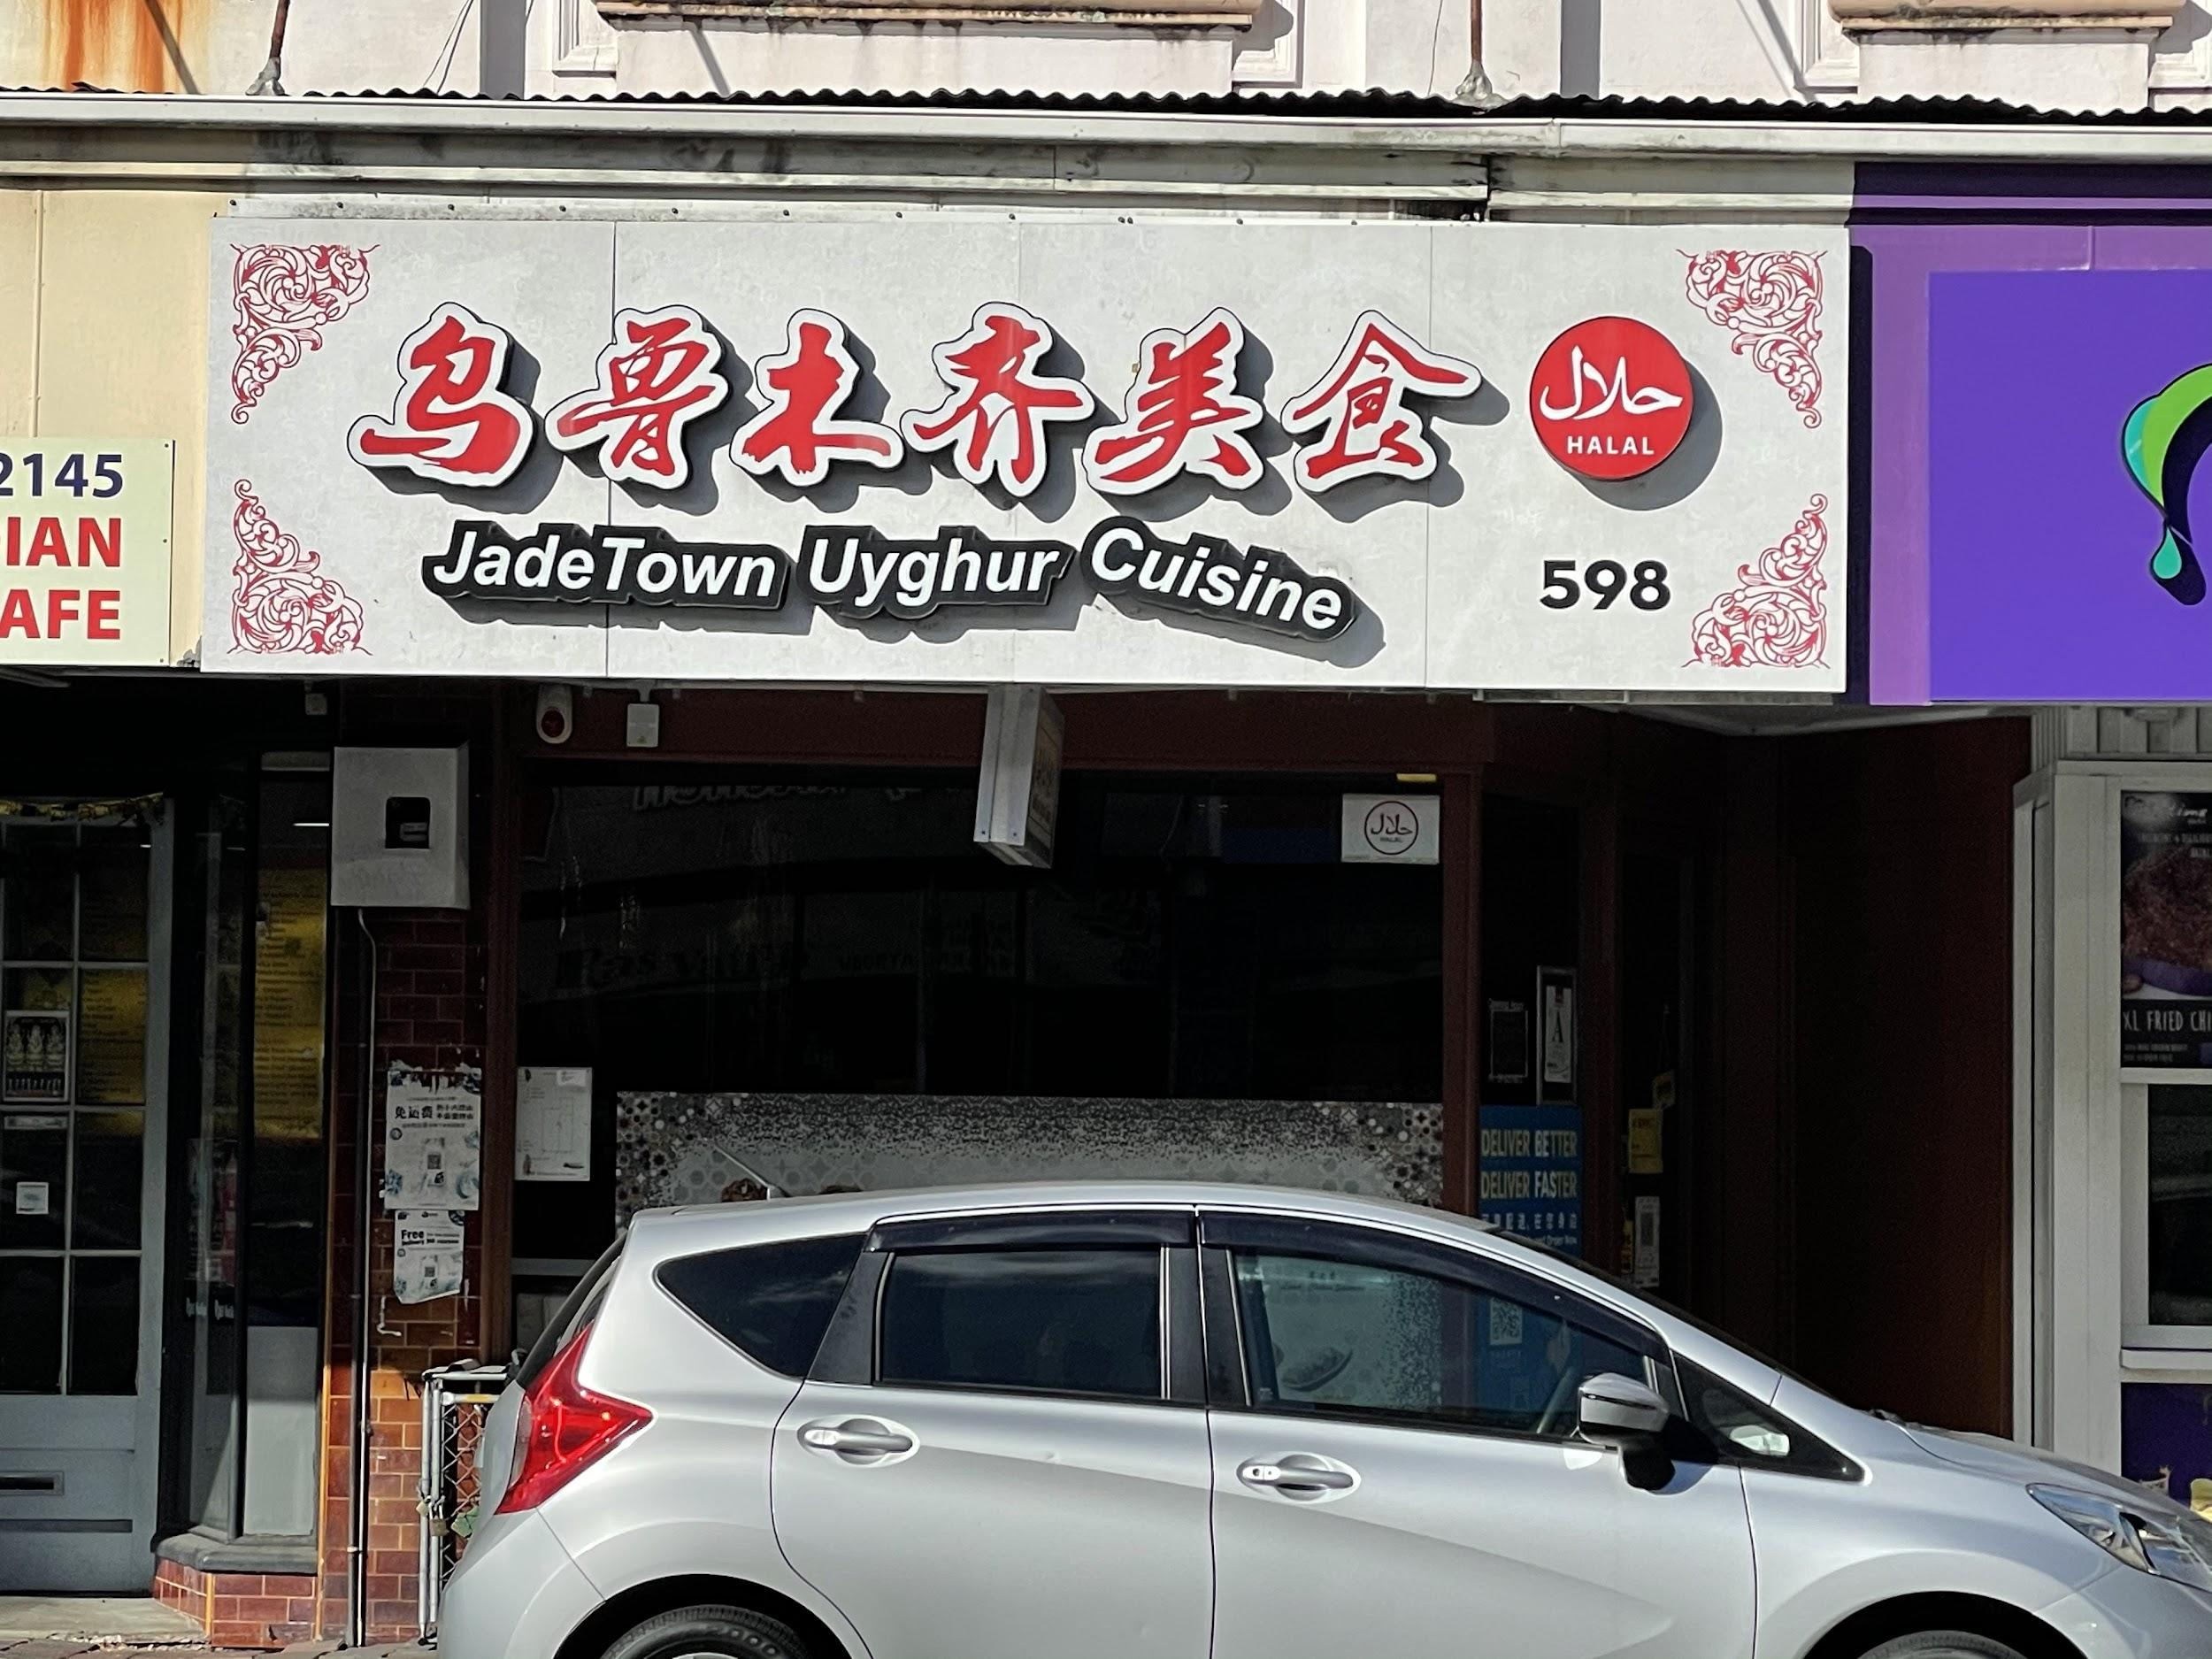

Discount Details: 10%off

Address: 598 Dominion Road, Mount Eden, Auckland 1041

Contact: 09-6235072

## **奶茶小吃甜点类：**

### 奶茶：

#### Own Tea 自茶



Discount Details: 10% off

Address: 13 Lorne Street, Auckland CBD

Contact：09-5578498

#### 

#### Chatime

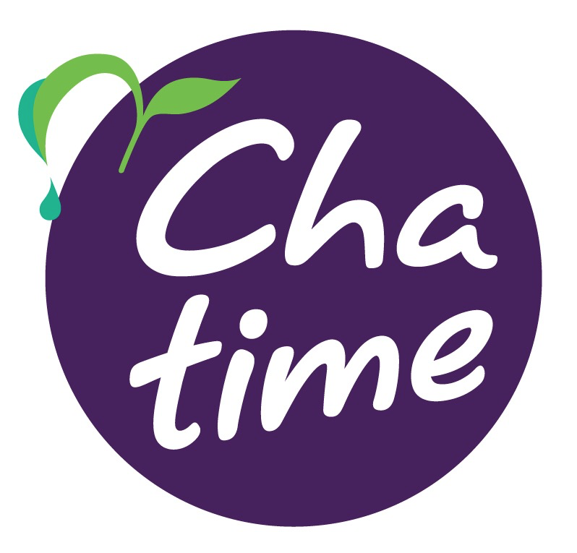

Discount Details: free upsize

Address: Shop 11/350 Queen Street (opposite of Event Cinema), Auckland Central

Contact：09-3205520

#### Songcha

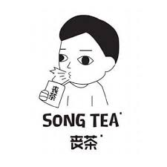

Discount Details: 12% off all drinks

Address: 448 Queen Street, Auckland Central

Contact：09-2187496

### 甜品：

#### Mellow COFFEE & DESSERT



Discount Details: 10% off (spend over $10)

Address: 42A-42D High St, Auckland

Contact: 09-3070707

#### 半糖主义

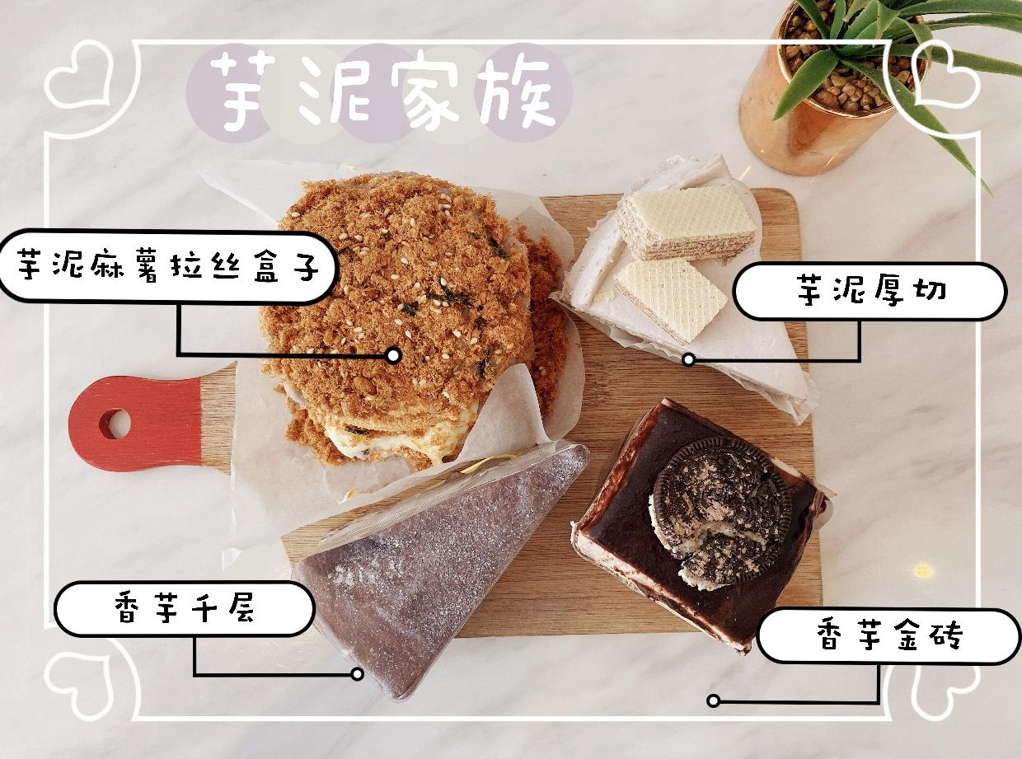

Discount Details: 10% off

Address: Shop 3/396 Queen Street 1010 Auckland CBD

Contact：09-3732649

### 小吃：

#### 功夫炸鸡

 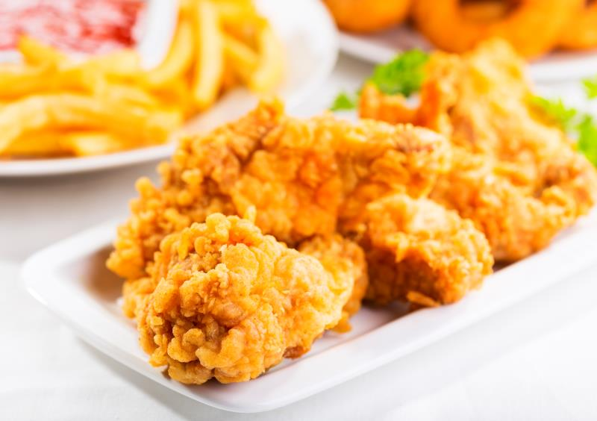

Discount details: 20% off

Address: 464 Queen Street, Auckland CBD, Auckland,1010

Contact: 0220994225

#### Kai



Discount Details: 5% off

Address:

7 Queen Street, Auckland CBD, Auckland 1010

1 Rutland Street, Auckland Central

Contact: 09-2222689, 0212397724

#### Plus Chicken



Discount Details: 10% off

Address: 7 Lorne Street, Auckland CBD, Auckland 1010

Contact: 09-3021211

#### Pophut

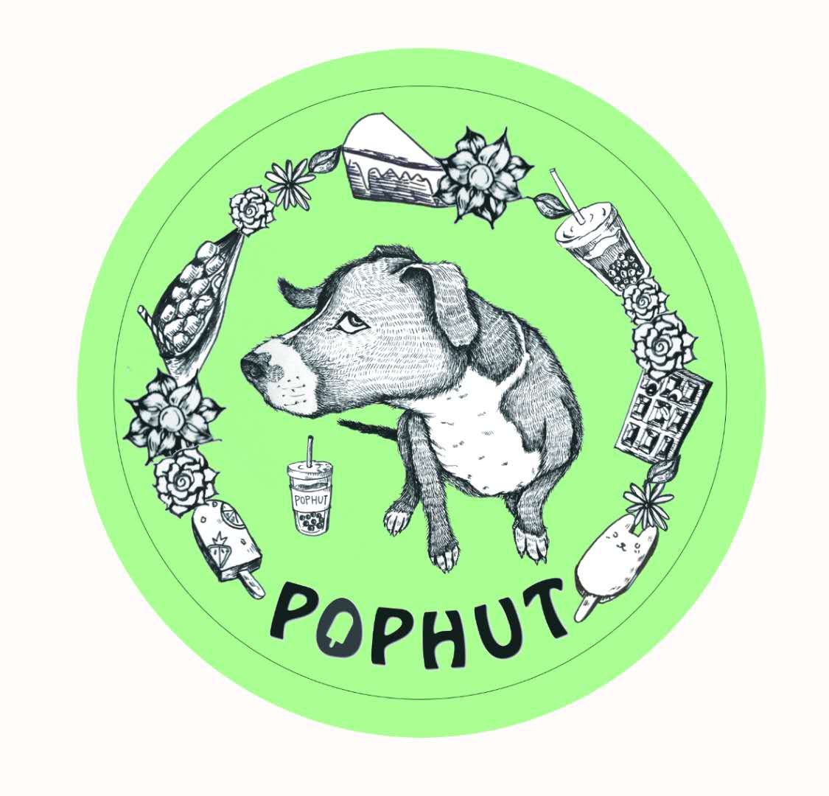

Discount Details: 10% off all food and drinks

Address: G9/239 Queen Street, Auckland CBD

Contact: 09-3779216

#### 

#### EGGLOO

### 

Discount Details: 10% off

Mt Albert 店

Address: 883 New North Rd, Mt Albert

Contact: 09-8468885

Sylvia Park 店

Address : Sylvia Park Shopping Center, 286 Mt Wellington Hwy

Contact: +642102572648

## 

## **生活类：**

#### 福润超市

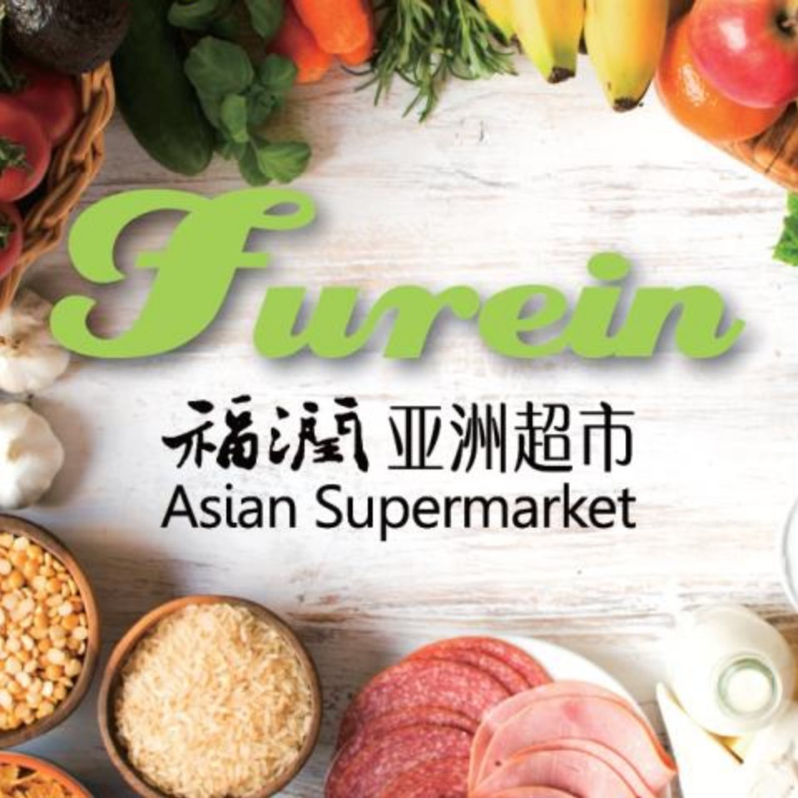

Discount Details: 5% off (spend over $30)

Address: Basement, Unit 1A/239 Queen Street, CBD, Auckland 1011

Note: Special offer excluded

#### In Vogue Blooms

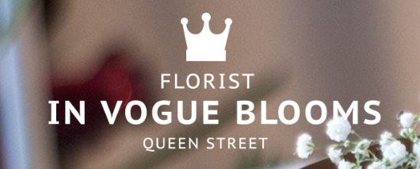

Discount Details: 10% off

Address: 280 Queen Street, Auckland, 1010

Contact：09-302 1222

#### Oxygen Floral



Discount Details: 10% off

Address: 280 Queen Street, Auckland, 1010

Contact：09-302 1222

#### 

#### The Cosmetic Store 药妆店

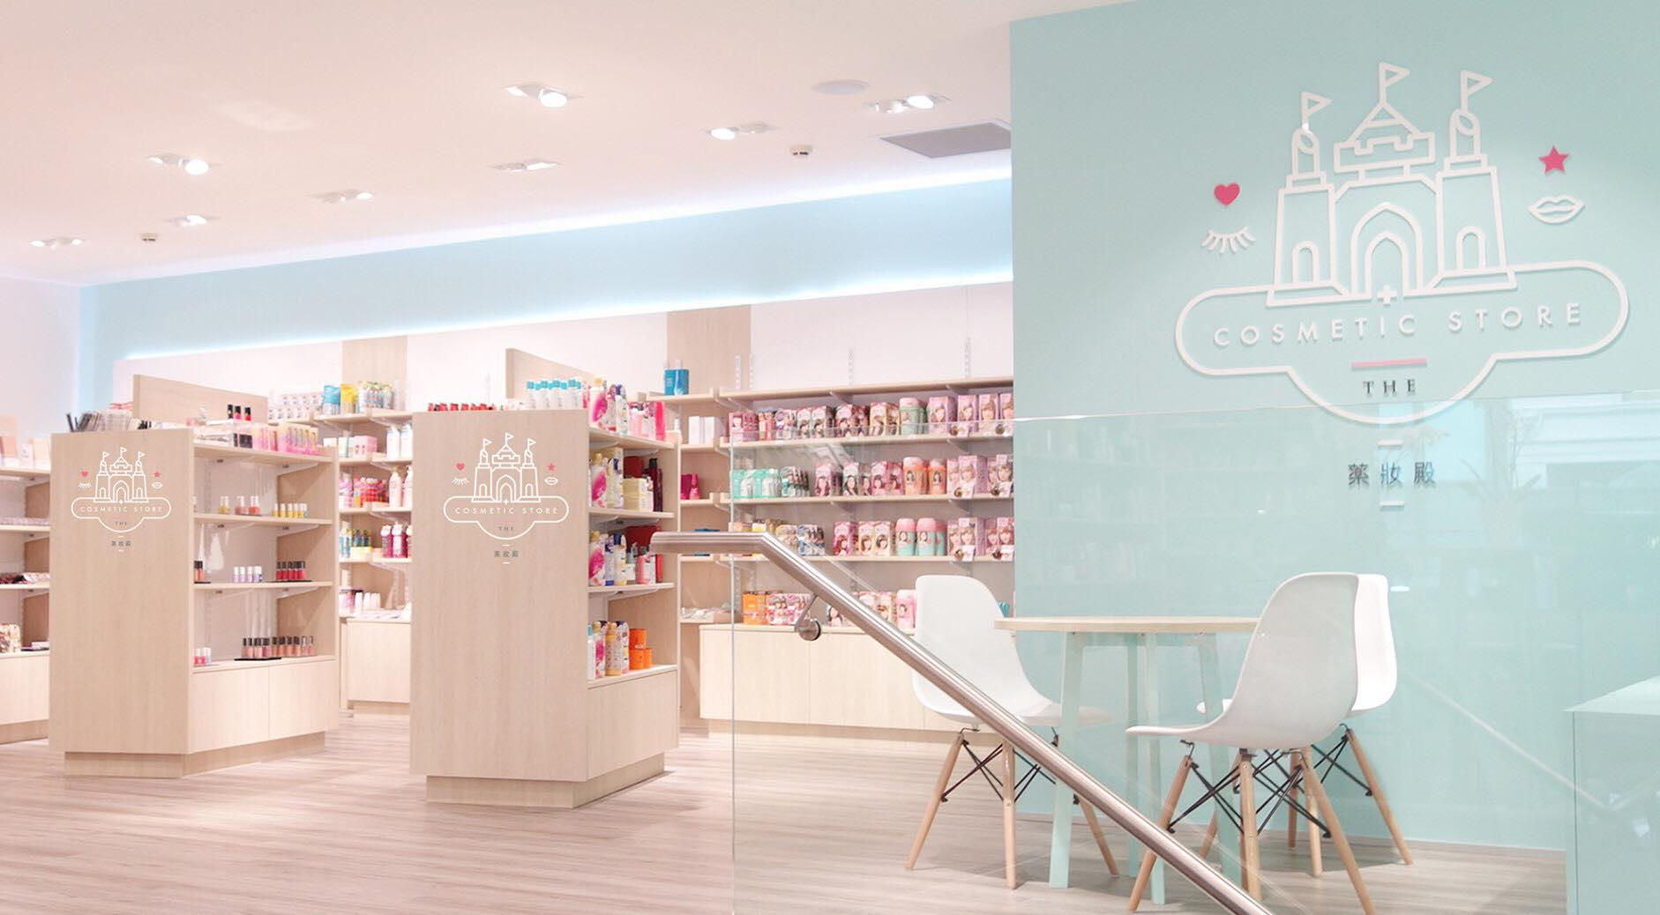

Discount Details: 5% off

Address: Level 1/10 Victoria St E, Auckland, 1010

Contact：09-3660199

#### Orange Pool Club

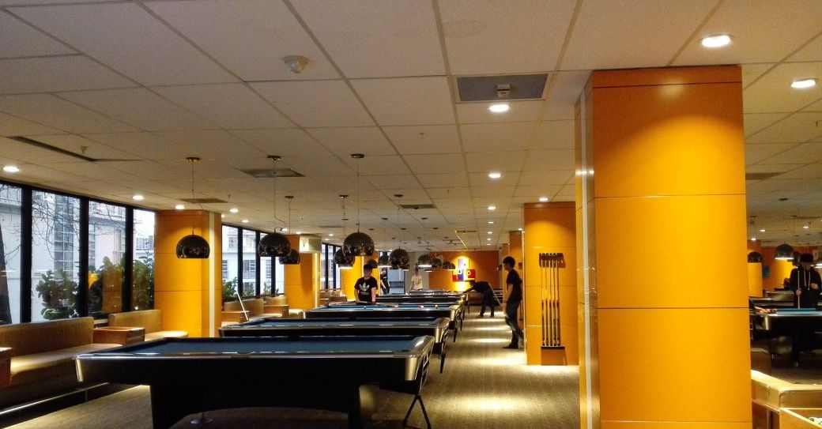

Discount Details: 30% Saturday 4-7:30 pm 10% on other time

Address: 9 City Road, Auckland CBD

Contact：09-3772335

#### 

#### 

#### Synergy Sport



Discount Details:

20% off Mon-Fri 10-5 Badminton/Basketball court

$3 table tennis entry

Address: Unit 3 44 Portage Road, New Lynn, Auckland

Contact：09-3920008